|  |  |  |  |  |  |  |  |
| --- | --- | --- | --- | --- | --- | --- | --- |
| **EXPERIENCE TYPE** | **ORGANIZATION / LOCATION** | **SUPERVISOR CONTACT INFO** | **START DATE** | **END DATE** | **TOTAL HOURS WORKED** | **DUTIES / RESPONSIBILITIES / OBSERVATIONS** | **POTENTIAL REFERENCE?** |
| **Animal** |  |  |  |  |  |  |  |
| **experience (no** |  |  |  |  |  |  |  |
| **veterinarian** |  |  |  |  |  |  |  |
| **involved)** |  |  |  |  |  |  |  |
| **Employment** |  |  |  |  |  |  |  |
| **(not animal-** |  |  |  |  |  |  |  |
| **related)** |  |  |  |  |  |  |  |
|  |  |  |  |  |  |  |  |
| **Extracurricular** |  |  |  |  |  |  |  |
| **activities** |  |  |  |  |  |  |  |
|  |  |  |  |  |  |  |  |
|  |  |  |  |  |  |  |  |
| **Research** |  |  |  |  |  |  |  |
|  |  |  |  |  |  |  |  |
|  |  |  |  |  |  |  |  |
|  |  |  |  |  |  |  |  |
| **Veterinary** |  |  |  |  |  |  |  |
| **experience** |  |  |  |  |  |  |  |
| **(with a** |  |  |  |  |  |  |  |
| **veterinarian)** |  |  |  |  |  |  |  |
| **Volunteer (not** |  |  |  |  |  |  |  |
| **animal-related)** |  |  |  |  |  |  |  |
|  |  |  |  |  |  |  |  |
|  |  |  |  |  |  |  |  |

**Tips from the AAVMC:**

* Veterinary schools are looking for applicants who have well-documented experiences and can articulate why they chose those experiences and what they have learned from those experiences
* Complete prerequisites at a pace in which you can maximize your learning and your grades while participating in nonacademic activities, whether that be extracurricular activities, employment, volunteer work, clubs, research, or animal/veterinary experiences
* **Experiences cannot fulfill more than one category**
* **Experiences can date from the first year of high school through application submission**
* **Research does not have to be animal-focused**

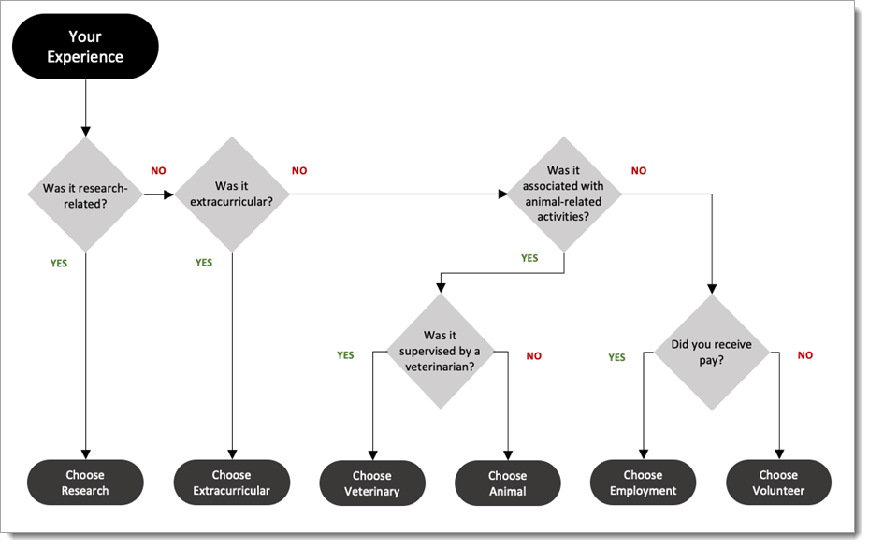**Chart from the VMCAS Applicant Help Center**

<https://help.liaisonedu.com/VMCAS_Applicant_Help_Center/Filling_Out_Your_VMCAS_Application/VMCAS_Supporting_Information/2_Experiences>